**Flames Season 3: Release Date and Other Details!** 

**Flames**, a *MX Player* original Television series directed by Apoorv Singh Karki and produced by Akansh Gaur, Puneet Waddan, and Arun Kumar. It became one of the highest rated television series by TVF. It’s first *season* was premiered on January 5, 2018 then the second *season* came in 2019 after so much demand from the audience. Now they’re demanding for the third *season*. And luckily there’s official announcement from the TVF side that the show will be renewed for its third *season*.

**Flames Season 3: Probable Cast**

Though there’s no official announcement regarding who’ll be casted in the *Flame*’s third *season* but still we can expect the protagonists to repeat their roles. There’ll be few more new characters but nothing is predictable. Few characters who’re likely to appear are:

Ritvik Sahore being **Rajat**

Tanya Maniktala being **Ishita**

Sunakshi Grover being Anusha

Shivam Kakar being Gaurav Pandey

Deepesh Sumitra Jagdish being Pradeep Kaushal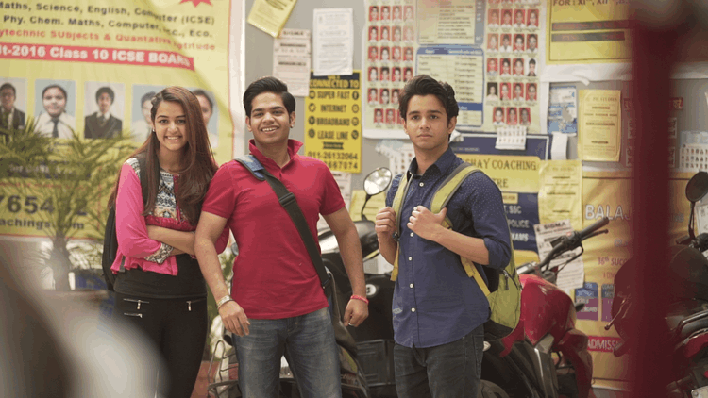

**Flames Season 3: Expected plot**

*Flames* revolves around the story of adolescence coaching affection between *Rajan* and *Ishita* who meet in an IIT coaching class from where the love story starts. *Rajat* fell in love with *Ishita* at first sight. First *season* mainly shows the growing affection between them and then in second *season* they start dating each other. The series is all about depicting the love from different scenarios for today’s youth generation, falsifying the image one have about that like love is all about having physical relation, or pleasures. We’re expecting 5 episodes to be there in **season 3** because other two *season*s were also having 5 episodes each.

**Flames Season 3: Release Date**

Since there’s no official news regarding the *release date*. So, we can expect the *season 3* to come by mid of 2021. Since, we might expect some delay because of covid-19. However, we still need to wait for any official announcement regarding the same. **Trailer** for *season 3* has not been released yet so till that time you can enjoy the *trailer* of the last *season* 😊

https://www.youtube.com/watch?v=SmcvDoEuSfM&list=PLbZboRRHE3b07-vPJgJu_Ykwwqwm8PdVr